Software version: V0.7 and above
Hardware version: YellowR16 standard configuration
Kit version: V1.0
Automated adaptation version: V1.0
DNBelab C-YellowR 16
Automated Operation Manual for High-throughput Single-cell 3' RNA Library Preparation Kit V3.0
Version History

Automated Version | Revision Date | Revised Summary
V1.0 | March 10, 2026 | First release
Tips: Please download the latest version of the Manual, and operate the kit according to the corresponding version.
Search the catalog number or product name, and download the Manual from www.mgi-tech.com/download/files

Table of Contents
Chapter 1. Product Information 4
1.1. Product Description 4
1.2. Applicable Software 4
1.3. Supporting Hardware 4
1.4. Applicable Reagent Kits 5
1.5. List of Customer-prepared Materials 5
1.6. Precautions 6
1.7. Overview of Full Workflow Automation for the DNBelab C Series High-throughput Single-cell 3' RNA Library Preparation Kit V3.0 7
Chapter 2. Conditions for Applying Automated Workflows 8
2.1. Precautions and Preparation Before Experiment 8
2.2. Sample Requirements 8
Chapter 3. Automated Standard Workflow for 3' RNA on the Single-Cell Library Preparation Integrated System 11
3.1 Preparations Before Instrument Use 11
3.2. Automated Workflow Setup 14
Chapter 4. Sequencing 29
4.1. MGISEQ-2000RS Sequencing Platform Experimental Procedure 29
4.2. Experimental Procedure of the DNBSEQ-T7RS Sequencing Platform 31
Appendix 32
Appendix A: Precautions Before Using DNA Clean Beads 32
Appendix B: Rules for the Use of Barcode Primer and Quantitative Reagents 33
Appendix C: Guidelines for Flexible-throughput Reagent Aliquoting 37
Appendix D: Guidelines for Preparation of Flexible-throughput Cell Phase and Magnetic Bead Phase 41
Appendix E: Reference Table of Consumable Usage for 1–8 Throughputs in the Entire Workflow 42
Appendix F: Silicone Pad for Replacing the PCR Cover Plate 44

Product Information

Product Description
The DNBelab C-YellowR 16 single-cell library preparation integrated system (abbreviated as DNBelab C-YellowR 16) is a system independently developed by MGI Tech that is designed for fully automated preparation of MGI single-cell libraries. It supports the entire workflow from droplet generation through DNB sequencing library preparation. This operation manual is intended to guide operators in executing automated workflows on the DNBelab C-YellowR 16 using the DNBelab C Series High-throughput Single-cell 3' RNA Library Preparation Kit V3.0 (catalog number: 940-002826-00, 16RXN).

Applicable Software
The software versions applicable to this manual are V0.7 and above.

Supporting Hardware
The standard configuration of DNBelab C-YellowR 16 includes the following hardware:
Table 1-1 DNBelab C-YellowR 16 Standard Configuration Hardware Types
Hardware | Location | Quantity
Quantification module | Pos 7 | 1
Magnetic stand | Pos 9 | 1
Reagent reservoir plate position | Pos 10 | 1
PCR module | Pos 11、12 | 1
Room temperature reagent plate position | Pos 13 | 1
Low temperature reagent plate position | Pos 14 | 1
Shaking module | Pos 15 | 1
Carrier plate position | Pos 16、17 | 2
Low temperature reagent cover plate position | Pos 19 | 1
Waste bin | Pos 20 | 1
Droplet generator | Pos 26 | 1

Applicable Reagent Kits
Kit type | DNBelab C Series High-throughput Single-cell 3' RNA Library Preparation Kit V3.0 (Box 1 Droplet Generation) | Cat. No.: 940-001820-00
Kit type | DNBelab C Series High-throughput Single-cell 3' RNA Library Preparation Kit V3.0 (Box 2 Droplet Generation) | Cat. No.: 940-001819-00
Kit type | DNBelab C Series High-throughput Single-cell 3' RNA Library Preparation Kit V3.0 (Box 3 Library Preparation) | Cat. No.: 940-001821-00
Kit type | DNBelab C Series Single-cell Library Preparation Sample Barcode Kit S | Cat. No.: 940-001920-00
Kit type | DNBelab C Series Flow cell H | Cat. No.: 940-002822-00

List of Customer-prepared Materials
Table 1-2 List of Customer-prepared Materials
Device | Vortex mixer
Device | Manual single-channel pipette (0.1-2.5μL、0.5-10μL、2-20μL、10-100μL、20-200μL、100-1000μL
Device | Manual 8-channel pipette (1-10μL、2-10μL、5-50μL、20-200μL)
Device | Centrifuge (Eppendorf, Cat. No. 5810R) or instrument with equivalent function
Device | 1.5 mL tube magnetic stand (Thermo Fisher, Cat. No. 12321D)
Device | 0.2 mL tube magnetic stand (New England Biolabs, Cat. No. S1515S)
Device | Nucleic acid fragment analyzer
Reagent | DNA-OFF SOLUTION (TAKARA, Cat. No. 9036)
Reagent | RNase Zap (AMBION, Cat. No. AM9782)
Reagent | 75% medical alcohol
Reagent | PBS，pH 7.4 (Gibco, Cat. No. 10010031)
Reagent | BSA (bovine serum albumin) (Sangon, Cat. No. A600332-0005)
Reagent | Trypan blue solution, 0.4% (Gibco, Cat. No. 15250061) or analytical reagent with equivalent function
Reagent | Nuclease-Free Water (NF water) (Ambion, Cat. No. AM9937)
Reagent | TE buffer，pH 8.0 (Ambion, Cat. No. AM9858)
Reagent | Anhydrous ethanol (analytical grade)
Reagent | DNBSEQ One-Step DNB Preparation Kit V4.0 (Cat. No. 940-001653-00)
Reagent | MGISEQ-2000RS High-throughput Sequencing Reagent Kit (FCL PE100) (Cat. No. 1000012554)
Reagent | MGISEQ-2000RS High-throughput Sequencing Reagent Kit (FCL PE150) (Cat. No. 1000012555)
Reagent | DNBSEQ-T7RS High-throughput Sequencing Reagent Kit (FCL PE100) V3.0 (Cat. No. 940-000269-00)
Reagent | DNBSEQ-T7RS High-throughput Sequencing Reagent Kit (FCL PE150) V3.0 (Cat. No. 940-000268-00)
Reagent | QubitTM ssDNA Assay Kit (Invitrogen, Cat. No. Q10212)
Reagent | QubitTM dsDNA HS Assay Kit (Invitrogen, Cat. No. Q32854)
Reagent | Supporting analytical reagent for nucleic acid fragment analyzer
Table 1-3 List of Customer-prepared Automation Materials
Consumable | 50μL pipette tip, conductive, with filter, boxed (MGI，Cat. No.091-000162-00)
Consumable | 200μL pipette tip, clear, with filter, boxed (MGI，Cat. No.091-000164-00)
Consumable | 1000μL pipette tip, clear, with filter, boxed (MGI，Cat. No.091-000377-00)
Consumable | 50 mL single-well reservoir and reservoir lid set (MGI，Cat. No.091-000375-00)
Consumable | 100 mL single-well reservoir and reservoir lid set (MGI，Cat. No.091-000374-00)
Consumable | 1.3 mL round-well U-bottom deep-well plate (MGI，Cat. No.1000004644)
Consumable | 1.2 mL round-well U-bottom deep-well filter plate (MGI，Cat. No. 091-000904-00)
Consumable | 0.2 mL 96-well full-skirt PCR plate (MGI，Cat. No. 091-000165-00)
Consumable | Breakable PCR 8-tube strips and caps (200μL) (MGI，Cat. No. 100-000016-00)
Consumable | MGISP-100 800μL breakable 8-tube strip (MGI，Cat. No.012-000887-00)
Consumable | Automated PCR instrument sealing pad (MGI，D-0190784)
Consumable | PCR plate sealing gasket (MGI，012-001381-00)
Consumable | 2 mL cryovial, PCR grade (MGI，Cat. No. 012-001189-00)
Consumable | 0.5 mL cryovial, PCR grade (MGI，Cat. No. 012-001190-00)
Consumable | 5 mL cryovial (with cap) (MGI，Cat. No. 100-000052-00)
Consumable | MGI 5 mL cryovial rubber stopper (MGI，Cat. No.012-000818-00)
Consumable | 0.5 mL clear thin-walled tube (Axygen，Cat. No. 091-000401-00)

Precautions
The current version supports full workflow experiments with flexible throughput of 1–8 samples.
Before the experiment, please be familiar with and master the operation methods and precautions of various instruments to be used.
Retrieve each component of the kit before use and place the Enzyme on ice after instantaneous centrifugation for later use. Thaw other components on ice, then mix them thoroughly by inverting them several times, and place them on ice for later use after instantaneous centrifugation.
To avoid cross-contamination of samples during manual operation, it is recommended to use pipette tips with filters and to replace the pipette tip when aspirating different samples.
Before and after each experiment, please perform cleaning according to section 3.1.1 of this manual.
All samples and reagents shall avoid direct contact with the skin and eyes. Avoid swallowing. Immediately rinse with large amounts of water and visit the hospital in a timely manner if swallowing occurs.
All samples and all wastes shall be disposed of in accordance with applicable regulations.
If you have any further questions, please contact MGI technical support: MGI-service@mgi-tech.com

Overview of Full Workflow Automation for the DNBelab C Series High-throughput Single-cell 3' RNA Library Preparation Kit V3.0
The current version of the DNBelab C-YellowR 16 single-cell library preparation integrated system supports flexible throughput of 1–8 samples per run, with a total run time of approximately 14 hours for 8 samples. The duration of each step and the corresponding stopping points are shown in the table below:
Table 1-4 Overview of the Entire Experimental Workflow
Operating Steps | Duration | Stopping Point and Storage Method
Sample processing | ~90 minutes | /
Loading of consumables and reagents | ~30 minutes | /
Droplet generation & reverse transcription | ~200 minutes | Stopping point: After completion of reverse transcription, the recovered droplets can be incubated at 2–8°C for up to 24 hours.
Demulsification & cDNA amplification | ~300 minutes | Stopping point: cDNA products and Oligo products can be stored at −25°C to −15°C for up to 6 months.
Oligo library construction & cDNA library construction | ~380 minutes | Stopping point: cDNA libraries and Oligo libraries can be stored at −25°C to −15°C for up to 6 months.
Pooling & make DNB | ~120 minutes | DNBs can be stored at 4°C for up to 48 hours.

Conditions for Applying Automated Workflows
This kit is intended for use with the DNBelab C-YellowR 16 single-cell library preparation integrated system to automate the entire workflow of the DNBelab C Series High-throughput Single-cell 3' RNA Library Preparation Kit V3.0. The current version supports runs with 1–8 samples.

Precautions and Preparation Before Experiment
The single-cell integrated system is recommended to be operated in a Class 100,000 or Class 300,000 cleanroom.
Laboratory personnel must properly wear surgical masks and disposable powder-free latex gloves. During the procedure, the skin on the wrist must not be exposed; if the gloves come into contact with any area outside the laminar flow hood, the glove surface must be thoroughly wiped with RNase-Zap before the experiment can be continued.
All samples in the experiment are required to be placed on an ice box.
Consumables such as tip, centrifuge tube and sterile water used in the experiment must be sterile, nucleic acid-free and nuclease-free, and the tip must be the low adsorption cartridge tip without nuclease; the consumables must be specially used and shall not be used for other purposes.
Please prepare reagents and consumables for each step in the following order: Instrument Cleaning, Reagent Preparation and Aliquoting, Consumable Loading, Reagent Loading, Preparation of the Cell Suspension, and Preparation of the Cell Phase and Magnetic Bead phase.

Sample Requirements

Cell Size
The recommended cell diameter is less than 60 μm.

Total Cell Count and Concentration Requirement
~ The recommended total cell input is 5,000 to 30,000.
~ The recommended loading quantity for cell line samples is 5,000~30,000.
~ The recommended loading quantity for PBMC samples and other tissue dissociation samples is 10,000~30,000.
Table 2-1 Recommended Cell Input
Target Input Cell Count (cells) | 5000 | 10000 | 20000 | 30000
Recommended Concentration (cells/μL) | 272 <N<1000 | 544 <N<2000 | 1087 <N<2000 | 1631 <N<2000
- Note: When determining the cell concentration, it is recommended to count viable cells, performing three independent counts to ensure accurate cell input.

Cell Requirements
Cells: Cell Viability > 80%, Cell Clumping Rate < 5%, Impurity Rate < 5%.
Nuclei: Cell Viability < 5%, Nuclei Clumping Rate < 5%, Impurity Rate < 5%.

Laboratory Preparation
Before starting the experiment, thoroughly wipe gloves, pipettes, workbench surfaces and instruments with RNase-Zap, paying particular attention to pipettes and the main work surface of the bench.
If using a laminar flow hood, switch on the hood lighting in advance and use DNA-OFF to thoroughly wipe the workbench surface and instruments, especially metal and plastic surfaces. After wiping, wait 10 min to allow DNA degradation, then switch off the lighting and turn on ultraviolet irradiation for at least 15 min for sterilization. Turn on the illumination and blower after sterilization.

Reagent Preparation
Table 2-2 Preparation Method for 10% BSA
Reagent Name | Usage
BSA Powder | 1 g
PBS (pH 7.4) | Dilute to a constant volume of 10 mL
After complete dissolution, filter using a syringe fitted with a 0.22 μm filter membrane, then store at -25°C to -15°C for up to 6 months. ~
Table 2-3 Preparation Method for PBS (containing 0.04% BSA)
Reagent Name | Usage
PBS | 49.8 mL
10% BSA | 200μL
~ Add the required amount in proportion, mix thoroughly, and store at 2°C-8°C for up to 1 month.

Preparation of Cell Suspension and Cell Counting
For different sample types, such as cell lines and solid tissues, prepare single-cell suspensions using appropriate dissociation methods. Wash cells twice with PBS (containing 0.04% BSA), resuspend in an appropriate volume of PBS (containing 0.04% BSA), then pass through a cell strainer of suitable mesh size. Measure and record the viability, impurity rate, clumping rate, and concentration of the cell suspension.
- Note:
[1] For mixing cell samples by pipetting, it is recommended to use wide-bore pipette tips.
[2] Use a cell counting chamber or hemocytometer to determine cell concentration. Accurate counting is essential; otherwise, the final yield will be affected. A minimum of three replicate counts is recommended.
[3] Recommendations on cell input and whether to use the instrument to make DNB: When using the single-cell integrated system to perform make DNB operations, the instrument currently pools libraries from different channels in equal amounts, resulting in similar sequencing data volumes per sample. Therefore, if the cell input differs between channels, each sample will receive a comparable amount of sequencing data, but the average data volume per cell will vary substantially. Therefore, it is recommended to keep the cell input consistent across all channels; 2.When using the single-cell integrated system for double-stranded library construction, and subsequent steps such as library pooling and make DNB are performed manually, the cell input per channel can be adjusted flexibly and will not be constrained by the final sequencing data volume. However, because the integrated PCR instrument can only set a single PCR cycle number per run, if cell input is flexibly adjusted across the 8 channels, the PCR cycle number must be chosen according to the sample that requires the highest number of PCR cycles.

Automated Standard Workflow for 3' RNA on the Single-Cell Library Preparation Integrated System
When running the DNBelab C Series High-throughput Single-cell 3' RNA Library Preparation Kit V3.0 Automated Standard Protocol on the DNBelab C-YellowR 16 Single-Cell Library Preparation Integrated System, you must follow the operating instructions described in this chapter. To ensure standardized operation, you need to perform the following steps in sequence: 1. Preparations Before Instrument Use; 2. Automated Workflow Setup. To avoid prolonged waiting after preparation of the magnetic bead phase and cell phase, which may compromise cell viability, be sure to load consumables, reagents, samples, and M8 slides onto the integrated system in this order. Once the samples have been loaded, immediately place the M8 slides in the designated positions to initiate droplet generation.

3.1 Preparations Before Instrument Use

Instrument Preparation
1) Before using the instrument for the first time, verify that all plate positions on the single-cell library preparation integrated system are correctly installed.
2) Before starting the experiment, complete the cleaning procedure as prompted by the instrument. Open the window and follow the instructions in step 5 of Appendix F to open the PCR cover plate. First, wipe the sealing gasket of the PCR cover plate with NF water, and then wipe the gasket again with 75% ethanol. Keep the PCR cover plate in an upright position.
3) Click "Clean" on the main interface to enter the cleaning interface. Ensure the console is cleared and the window is closed, then check the "Clear Console" box. Click "Start," then click "OK" in the pop-up window to initiate the instrument cleaning process. The cleaning duration is 30 minutes.
4) After the instrument cleaning is completed, close the cover plate and shut the window according to the instructions in step 8 of Appendix F.

Consumables Preparation
After cleaning, refer to Table 3-1 to retrieve the automated consumables required for a single run of the single-cell library construction workflow and place them at room temperature for later use (the table below lists the types and quantities of consumables required for one complete run of 8 samples; consumables for other throughputs are provided in the appendix).

Table 3-1 List of Self-provided Consumables Required for Automated Single-cell Library Construction
Name of Automation Consumables | Brand | Cat. No.: | Quantity
50μL pipette tip, conductive, with filter, boxed | MGI | 091-000162-00 | 4
200μL pipette tip, clear, with filter, boxed | MGI | 091-000164-00 | 5
1000μL pipette tip, clear, with filter, boxed | MGI | 091-000377-00 | 1
50 mL single-well reservoir and reservoir lid set | MGI | 091-000375-00 | 5
100 mL single-well reservoir and reservoir lid set | MGI | 091-000374-00 | 1
1.3 mL round-well U-bottom deep-well plate | MGI | 1000004644 | 2
1.2 mL round-well U-bottom deep-well filter plate | MGI | 091-000904-00 | 1
PCR plate sealing gasket | MGI | 012-001381-00 | 1
0.2 mL 96-well full-skirt PCR plate | MGI | 091-0000165-00 | 3
Breakable PCR 8-tube strips and caps (200 μL) | MGI | 100-000016-00 | 1
MGISP-100-800 μL breakable 8-tube strips | MGI | 012-000887-00 | 1
2.0 mL cryovial, PCR grade | MGI | 012-001189-00 | 4
0.5 mL cryovial, PCR grade | MGI | 012-001190-00 | 4
5 mL cryovial (with cap) | MGI | 100-000052-00 | 8
MGI 5 mL cryovial rubber stopper | MGI | 012-000818-00 | 8
0.5 mL clear thin-walled tube | Axygen | 091-000401-00 | 1
M8 slide | MGI | 940-002822-00 | 4

Reagent Preparation
From the corresponding kit, retrieve the following reagents according to the actual required quantities. Mix the enzyme, cell beads, and index carrier thoroughly by inverting, briefly centrifuge, and then place them on ice for later use. After thawing at room temperature, vortex the other components thoroughly, briefly centrifuge, and then place them on ice for later use.
Table 3-2 Reagent Preparation List
Kit type | Component information | Cap color | Specification and quantity
DNBelab C Series High-throughput Single-cell RNA Library Preparation Kit Set V3.0 (Box 1: Droplet Generation)  (Catalog No.: 940-001820-00) | Cell Beads-V3 | Natural color | 560 μL/tube * 1 tube
 | Index Carrier | Natural color | 280 μL/tube * 1 tube
 | Lysis Buffer-V3 | Natural color | 72 μL/tube * 1 tube
 | Breakage Reagent | Brown | 800 μL/tube * 1 tube
 | P100 Oil | Natural color | 7.6 mL/bottle * 1 bottle
 | DNA Clean Beads | Natural color | 8.352 mL/bottle * 1 bottle
DNBelab C Series High-throughput Single-cell RNA Library Preparation Kit Set V3.0 (Box 2: Droplet Generation)  (Catalog No.: 940-001819-00) | Beads Buffer | Natural color | 728 μL/tube * 1 tube
 | Cell Solution-V3 | Natural color | 142 μL/tube * 1 tube
 | RT Primer-V3 | Natural color | 32 μL/tube*1 tube
 | DIR Regent-V3 | Natural color | 13 μL/tube * 1 tube
 | RT Enzyme-V3 | Natural color | 64 μL/tube*1 tube
 | RNase Inhibitor | Natural color | 132 μL/tube * 1 tube
 | cDNA Amp Enzyme | Natural color | 400 μL/tube * 1 tube
 | cDNA Amp Primer-V3 | Natural color | 33 μL/tube * 1 tube
DNBelab C Series High-throughput Single-cell RNA Library Preparation Kit Set V3.0 (Box 3: Library Preparation)  (Catalog No.: 940-001821-00) | Frag Enzyme-V3 | Natural color | 80 μL/tube * 1 tube
 | Frag Buffer-V3 | Natural color | 40μL/tube * 1 tube
 | DNA Ligase-V3 | Natural color | 80 μL/tube * 1 tube
 | Ligation Buffer-V3 | Natural color | 160μL/tube * 1 tube
 | scRNA Adapter-V3 | Natural color | 40μL/tube * 1 tube
 | PCR Amp Enzyme | Natural color | 600μL/tube * 1 tube
DNBelab C Series Slide H  (Cat. No.: 940-002822-00) | Slides | / | 8 slides/box * 1 box
SDNBelab C Series Single-cell Library Preparation Sample Tagging Kit  (Cat. No.: 940-001920-00) | Barcode Primer-1~8 | Natural color | 8-row strip * 1 set
 | Barcode Primer-9~16 | Natural color | 8-row strip * 1 set
 | Barcode Primer-17~24 | Natural color | 8-row strip * 1 set
 | Barcode Primer-25~32 | Natural color | 8-row strip * 1 set
DNBSEQ One-Step DNB Preparation Kit V4.0  (Cat. No.: 940-001653-00) | TE Buffer | Green | 300μL/tube * 1 tube
 | DNB Preparation Buffer (OS-SB-V4.0) | Yellow* | 80 μL/tube * 1 tube
 | DNB Polymerase Mixture I (OS-V4.0) | black | 160μL/tube * 1 tube
 | DNB Polymerase Mixture II (OS-V4.0) | Orange | 8μL/tube * 1 tube
 | DNB Termination Buffer | Blue | 100μL/tube * 1 tube
- Note: [1] Retrieve the DNA Clean Beads from storage in advance and equilibrate them at room temperature for at least 30 minutes. Vortex thoroughly before use.
[2] Retrieve Lysis Buffer-V3 from storage in advance and equilibrate it at room temperature until all crystals in the solution are completely dissolved.
[3] For the one-step DNB preparation reagents, aliquot the required volumes according to the amounts indicated in the software or in the appendix of this manual.
[4] Retrieve the P100 Oil used for droplet generation in advance and equilibrate it to room temperature.

Sample Preparation
After placing all consumables and reagents in their corresponding positions on the instrument, proceed to sample preparation.
1) The current version of the single-cell library preparation integrated system can construct single-cell libraries for 1–8 samples. Process the samples according to the specified sample handling requirements.
2) After sample processing is completed, resuspend the samples in PBS (containing 0.04% BSA), perform cell counting, and then place the samples on ice until use.
3) Refer to Appendix D of this manual to prepare the magnetic bead phase and the cell phase, and keep them on ice until use.
- Note: Each cell phase and magnetic bead phase must be prepared with a 1.13-fold excess to account for system loss.

Automated Workflow Setup

Software Login
Double-click 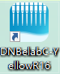 to open [DNBelabC-YellowR16]. The user login interface shown in Figure 3-1 will appear. Enter the username [user] and password [123456], then click "Login" to automatically start the initialization process.
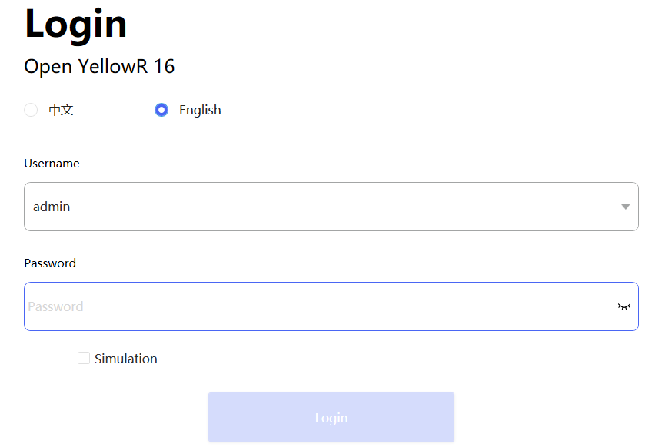
Figure 3-1 User Login Interface
- Note: Do not click "Run Simulation" on the login screen. If instrument initialization fails, check whether the instrument is powered on and whether the software has been opened multiple times. You may try restarting the software. If the issue persists, please contact technical support.
- Note: Ensure that all modules under the path Main interface → Device Maintenance → Device Settings → Module Settings are set to the "Real" state.

Software Main Interface
After successful initialization, the software main interface shown in Figure 3-2 will be displayed. On the main interface, if the experimental workflow to be run requires low temperature reagents, first switch on the low temperature module. The background of the low temperature module will turn green as shown in the figure and the temperature will automatically decrease to 4℃. Click [3'RNA] to enter the workflow setup interface.
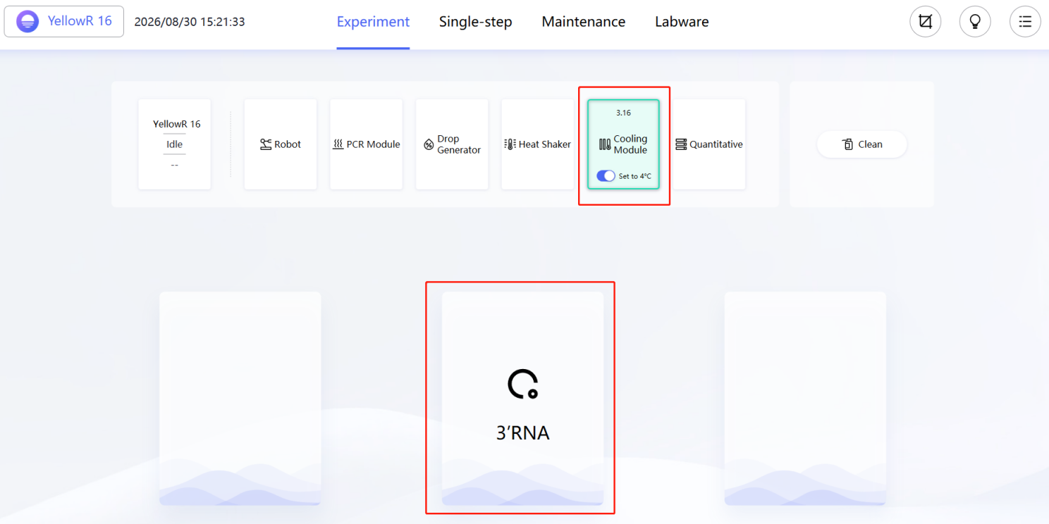
Figure 3-2 Software Main Interface

Workflow Setup
1) After entering the workflow setup interface shown in Figure 3-3, first select the experimental nodes to be executed in the "Select run node" section according to the experimental plan, and tick "√" in front of the name of each required experimental node.
2) Reference for cDNA product amplification cycle number
The required number of PCR cycles varies depending on the sample type and the number of input cells. When sample quality is suboptimal, it is recommended to use a higher number of cycles within the suggested range.
For cell line samples (input of 10,000–20,000 cells), it is recommended to use 11–13 cycles.
For PBMC samples (input of 10,000~20,000 cells), it is recommended to use 15~17 cycles.
For cells and nuclei derived from solid tissues (input of 10,000~20,000 cells), 18–20 cycles should be used depending on sample quality.
- Note: If two or more experimental nodes are selected, the selected nodes must be consecutive; otherwise, the experimental workflow cannot be successfully created.
- Note: If the number of samples is odd, one additional sample slide will be consumed. Please try to prepare an even number of samples before starting the run.
3) Based on the actual number of samples, sample type, and sequencing scheme, select the corresponding parameter settings under "Set running parameters". For specific recommended selections, configure the settings according to the workflow setup instructions below and Table 3-3.
- Note: If the selected workflow does not include Pooling & Make DNB, DNB-related parameters do not need to be configured, and options for DNB preparation parameters will not be displayed under "Set running parameters."
- Note: When setting the number of DNB samples per tube, if the number of DNB samples per tube cannot be evenly divided into the total number of samples being run, the remaining samples will not undergo DNB preparation. Example: If the total number of samples is 7 and the number of DNB samples per tube is 4, only the libraries of the first 4 samples will be pooled for DNB preparation, and the remaining 3 samples will not be prepared into DNB. It is recommended that the number of DNB samples per tube be kept consistent with the total number of samples. If the recommended pooling strategy is not followed, the workflow may report an error due to an insufficient number of pipette tips.

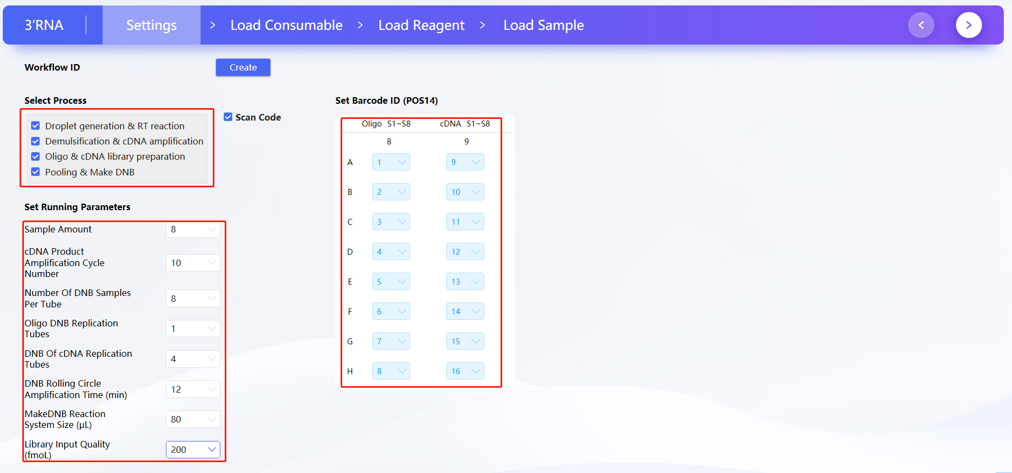
Figure 3-3 Workflow Setup Interface

Workflow setup instructions:
Run nodes: You can choose to run all 4 nodes, select 2 or 3 consecutive nodes, or run only a single node.
Sample number: In the current version, 1–8 samples can be processed in a single run.
cDNA cycle number: Select different cycle numbers according to the sample type. Select the cycle number according to “2) cDNA product amplification cycle number reference” in this section.
Number of DNB samples per tube: Keep consistent with the total number of samples. When pooling different libraries, refer to Appendix B for instructions on the use of scRNA barcode primers.
Number of Oligo DNB replication tubes: 1;
Number of cDNA DNB replication tubes: 4;
DNB rolling circle amplification time (min): 12, 30. Refer to Table 3-3 for specific parameter selection.
DNB preparation reaction volume (μL): 80, 100. Refer to Table 3-3 for specific parameter selection.
cDNA library input amount (fmol): 120, 200. Refer to Table 3-3 for specific parameter selection.

Table 3-3 Reference Table for DNB Preparation Parameters
Sequencing Platform | Sequencing Reagent Kit Name | Sequencing Reagent Kit Catalog Number | DNB Rolling Circle Amplification Time (min) | DNB Preparation Reaction Volume (μL) | Library Input Amount (fmol)
MGISEQ-  2000 | MGISEQ-2000RS High-throughput Sequencing Reagent Kit (FCL PE100) | 1000012554 | 30 | 100 | 120
MGISEQ-  2000 | MGISEQ-2000RS High-throughput Sequencing Reagent Kit (FCL PE150) | 1000012555 | 30 | 100 | 120
DNBSEQ-T7RS | DNBSEQ-T7RS High-throughput Sequencing Reagent Kit (FCL PE100) V3.0 | 940-000269-00 | 30 | 100 | 120
DNBSEQ-T7RS | DNBSEQ-T7RS High-throughput Sequencing Reagent Kit (FCL PE150) V3.0 | 940-000268-00 | 12 | 80 | 200
4) Set the barcode IDs. Two columns of barcodes need to be placed, with the following labeling rules: the 8th column of POS14 barcodes labels the Oligo libraries of samples 1–8; the 9th column of POS14 barcodes labels the cDNA libraries of samples 1–8. For detailed barcode labeling rules, refer to Table 3-4.
Table 3-4 Barcode Labeling Instructions for Samples 1–8
Workbench Position | Pos14 column 8 barcode labeling | Pos14 column 9 barcode labeling
A: | Oligo library of sample 1 | cDNA library of sample 1
(B √) | Oligo library of sample 2 | cDNA library of sample 2
C. | Oligo library of sample 3 | cDNA library of sample 3
D. | Oligo library of sample 4 | cDNA library of sample 4
E. | Oligo library of sample 5 | cDNA library of sample 5
F | Oligo library of sample 6 | cDNA library of sample 6
g | Oligo library of sample 7 | cDNA library of sample 7
(h) | Oligo library of sample 8 | cDNA library of sample 8
5) After configuring the run nodes, run parameters and barcode numbers and verifying that they are correct, click the button  in the upper right corner of the current page to proceed to the consumables loading step.

Consumables Loading
This section is intended to guide users in the correct placement of all consumables used in the experiment.
- Based on the parameters configured in the previous step, the integrated system will automatically calculate the required quantities of consumables and display them on the virtual workbench corresponding to the physical workbench, as shown in the blue area of the virtual workbench in Figure 3-4 (illustrated for 8 samples). Users should place the specified types and quantities of consumables at the designated positions according to the virtual workbench, the consumables list on the left, and the instructions in Table 3-5. The schematic diagram of slide loading is shown in Figure 3-5.
- Note: To reduce the probability of droplet generation causing slide well clogging, place the M8 slide in the corresponding position on the instrument immediately before starting the experimental workflow; when placing any pipette tips on the integrated system, remove the lid from each pipette tip box.
2) POS22–POS30 (except POS26) are stacking plate positions. The number shown in the blue background in the upper right corner of each plate position in Figure 3-4 indicates how many new pipette tip boxes must be stacked at that plate position. The positioning posts around each stacking plate position have grooves. First remove the lid from the pipette tip box, then place the box so that it is aligned with the grooves on the positioning posts.
3) After placing all consumables as required on the workbench and confirming that the layout is correct, click the button in the upper right corner of the current page to proceed to the reagent loading step.
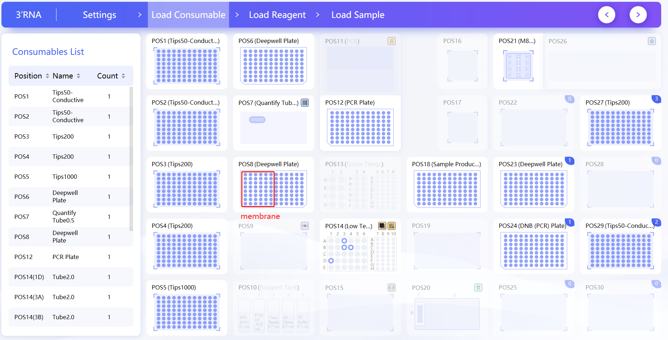
Figure 3-4 Consumables Loading Interface
Table 3-5 Correspondence Between Plate Positions and Consumable Names
Workbench Position | Plate Position Description | Official Name of Consumables | Consumables Name Displayed by Instrument
POS1 | Standard Plate Position | 50μL pipette tip, conductive, with filter, boxed | Tips50 - Conductive
POS2 | Standard Plate Position | 50μL pipette tip, conductive, with filter, boxed | Tips50 - Conductive
POS3 | Standard Plate Position | 200μL pipette tip, clear, with filter, boxed | Tips200
POS4 | Standard Plate Position | 200μL pipette tip, clear, with filter, boxed | Tips200
POS5 | Standard Plate Position | 1000μL pipette tip, clear, with filter, boxed | Tips1000
POS6 | Standard Plate Position | 1.3 mL round-well U-bottom deep-well plate | Deepwellplate
POS7 | Quantification module | 0.5 mL clear thin-walled tube | Quantitative Tube 0.5
POS8 | Standard Plate Position | 1.2 mL round-well U-bottom deep-well filter plate | Deepwellplate
POS9 | Magnetic Stand Module | / | /
POS10 | Reagent reservoir plate position | 50 mL single-well reservoir and reservoir lid set | /
POS11 | PCR Instrument Module | / | /
POS12 | PCR Instrument Module | 0.2 mL 96-well full-skirt PCR plate | PCR Plate
POS13 | Room temperature reagent module | 5 mL cryovial (with cap) | 5 mL centrifuge tube
POS13 | Room temperature reagent module | MGISP-100 800μL breakable 8-tube strip | 8-tube strips (800 μL)
POS14 | Low temperature reagent module | 2.0 mL cryovial, PCR grade | 2.0 mL Cryovial
POS14 | Low temperature reagent module | 0.5 mL cryovial, PCR grade | 0.5 mL Cryovial
POS14 | Low temperature reagent module | Breakable PCR 8-tube strips and caps | 8-tube strips (200 μL)
POS15 | Temperature-controlled oscillation module | / | /
POS16 | M8 slide plate position 1 | / | /
POS17 | M8 slide plate position 2 | / | /
POS18 | Product plate module | 0.2 mL 96-well full-skirt PCR plate | PCR plate - product plate
POS19 | Low temperature reagent cover plate | / | /
POS20 | Waste bin | 100 mL single-well reservoir and reservoir lid set | /
POS21 | M8 droplet generation module | DNBelab C Series Slide H | M8 slide
POS22 | Stacking plate positions | / | /
POS23 | Stacking plate positions | 1.3 mL round-well U-bottom deep-well plate | Deepwellplate
POS24 | Stacking plate positions | 0.2 mL 96-well full-skirt PCR plate | PCR Plate
POS25 | Stacking plate positions | / | /
POS26 | M8 droplet generation module | / | /
POS27 | Stacking plate positions | 200μL pipette tip, clear, with filter, boxed | Tips200
POS28 | Stacking plate positions | / | /
POS29 | Stacking plate positions | 50μL pipette tip, conductive, with filter, boxed | Tips50 - Conductive
POS30 | Stacking plate positions | / | /
- Note: If the workflow includes the second step "demulsification & cDNA amplification", a 1.2 mL round-well U-bottom filter-membrane deep-well plate (catalog number: 091-000904-00) must be placed at position POS8, and the consumables at the other plate positions remain unchanged; if the selected workflow does not include the second step, a 1.3 mL round-well U-bottom deep-well plate (catalog number: 1000004644) must be placed at position POS8.
- Note: For the 0.2 mL 96-well full-skirt PCR plate at POS18, the PCR plate sealing pad (catalog number: D-191626) must be fitted onto the PCR plate before placing it in the corresponding position on the instrument.
- Note: It is recommended to replace the PCR sealing pad (catalog number: D-0190784) on the top cover plate of the PCR module after every 20 runs. For the replacement procedure, please refer to Appendix F.
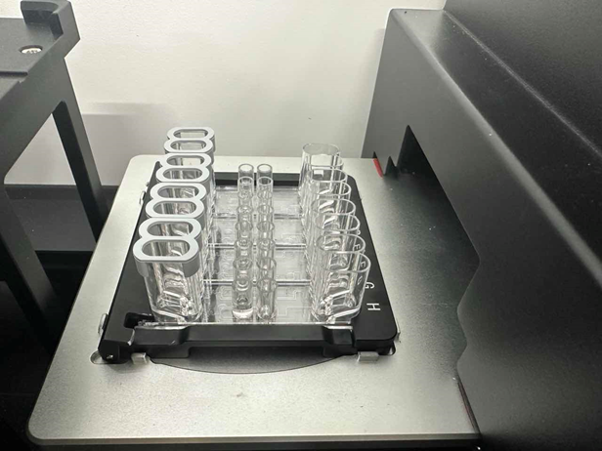
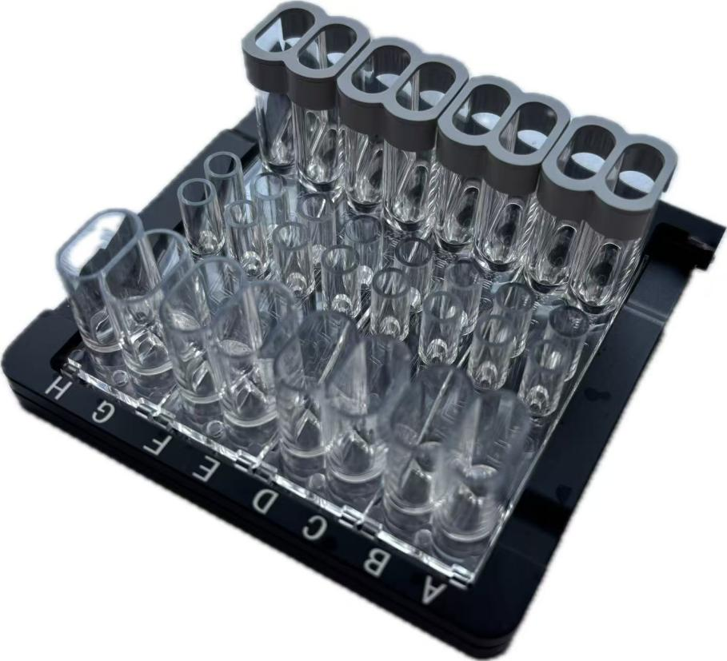
Figure 3-5 Schematic Diagram of Slide Loading
Slide loading instructions: The slide must be placed on the carrier plate, with the end of the carrier plate bearing letters oriented to the right.

Reagent Loading
This section is intended to guide users in the correct placement of all reagents used in the experiment.
1) Based on the workflow setup selected in 3.2.3, this step automatically calculates all reagents required for the selected workflow and displays them on the virtual workbench corresponding to the physical workbench, as shown in Figure 3-6 (the figure shows the reagents required for 8 samples). Reagents can be loaded in sequence into the reagent reservoirs, room temperature reagent positions, and low-temperature reagent positions according to the on-screen prompts. Click the room temperature reagent and low temperature reagent positions highlighted by the red box in Figure 3-6 to view an enlarged image.
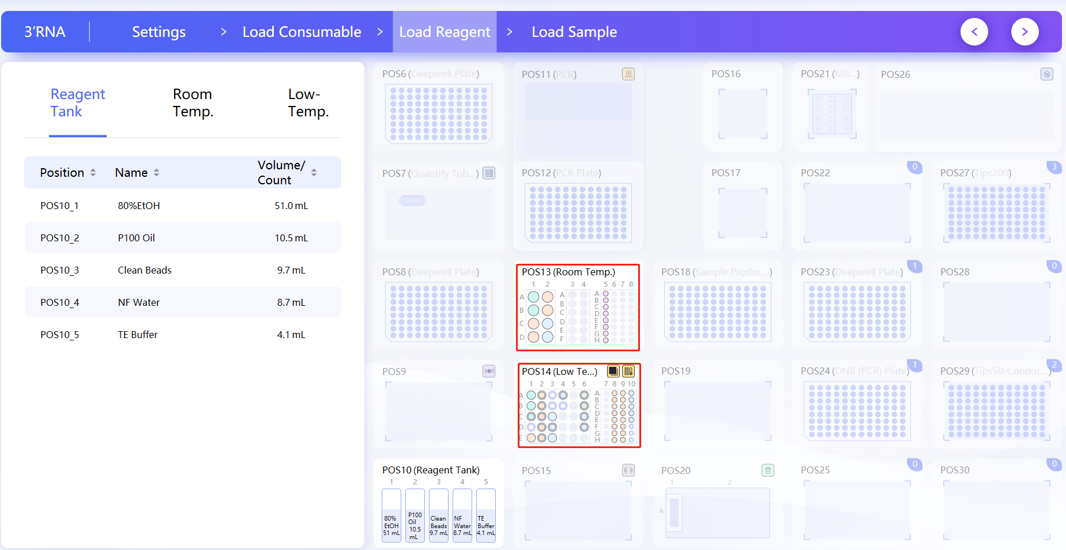
Figure 3-6 Reagent Reservoir Loading Interface
- Click the room temperature reagent in the red box shown in Figure 3-6 to display detailed information about the POS13 room temperature reagent, as shown in Figure 3-7 (the figure shows the reagents required for 8 samples). The left side shows the reagent position, reagent name, and reagent filling volume, while the large image in the middle is a schematic diagram of the reagent positions. Users can also click a specific experimental node (marked by the red box in Figure 3-7). At this point, only the room temperature reagents used in the selected node will be displayed.
- Note: The magnetic bead phase must be subjected to droplet generation within 10 minutes after preparation. Please prepare and load it together with the cell phase in the next sample loading step. The magnetic bead phase does not need to be loaded in this step.

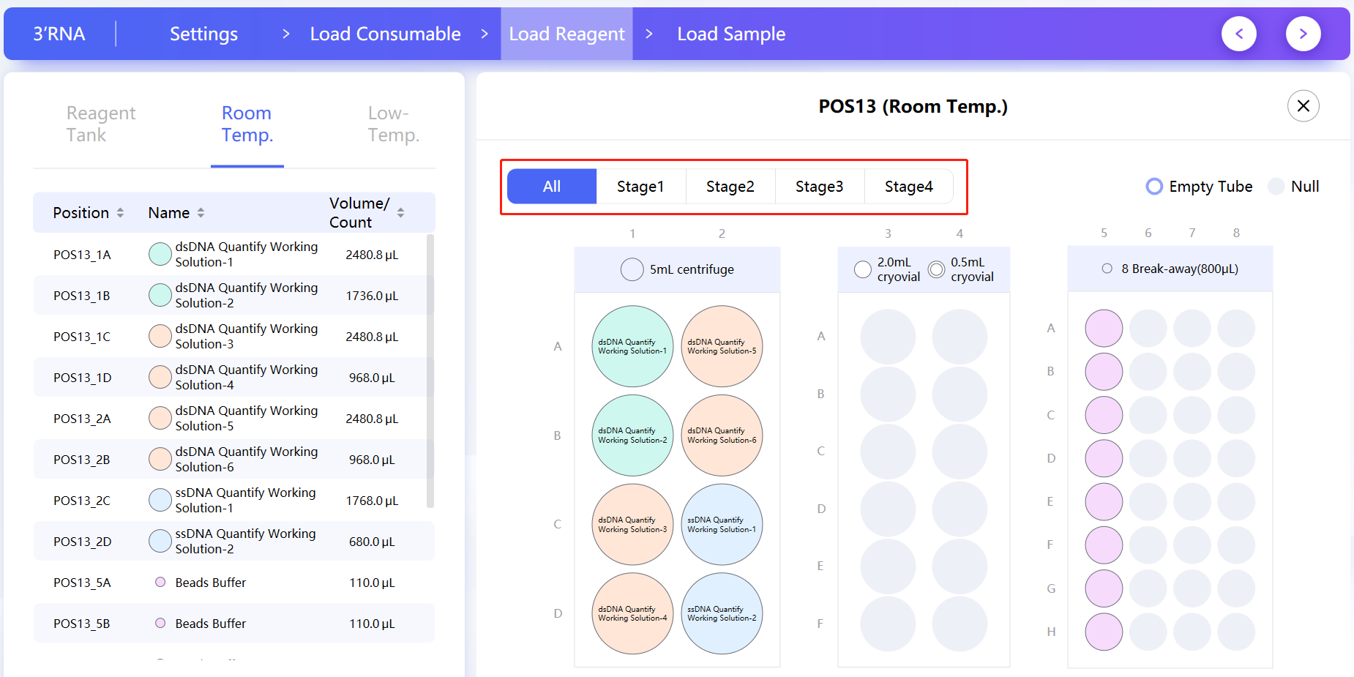
Figure 3-7 Room Temperature Reagent Loading Interface
- Click the low temperature reagent in the red box shown in Figure 3-6 to display detailed information about the POS14 low temperature reagent, as shown in Figure 3-8 (the figure shows the reagents required for 8 samples). The left side shows the reagent position, reagent name, and reagent filling volume, while the large image in the middle is a schematic diagram of the reagent positions. Users can also click a specific experimental node (marked by the red box in Figure 3-8). At this point, only the low temperature reagents used in the selected node will be displayed.
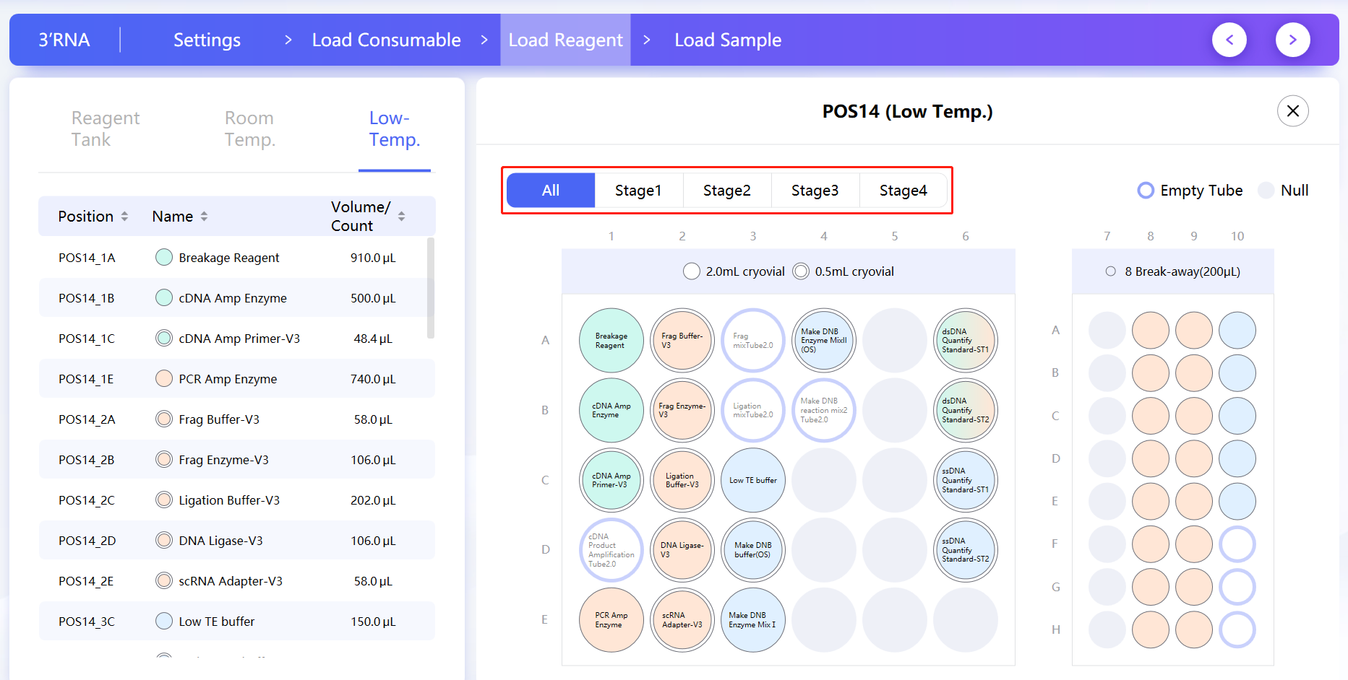
Figure 3-8 Low Temperature Reagent Loading Interface
- Note: [1] When running 8 samples, one new tube of low temperature reagent can be retrieved directly from the kit, the cap removed, and placed in the corresponding position on the instrument. The actual filling volume of the reagent is greater than the labeled volume, which already includes instrument redundancy and meets the sample loading requirements of the single-cell integrated system. No additional reagent needs to be added.
[2] A single black circle indicates that the reagent is loaded into a 2.0 mL cryovial, a double black circle indicates that the reagent is loaded into a 0.5 mL cryovial, and a single purple circle indicates that an empty 2.0 mL cryovial needs to be placed.
[3] After the low temperature reagent is loaded, place the low temperature reagent cover plate on the POS14 low temperature reagent module.
4) After placing all reagents according to the workbench layout requirements and confirming that everything is correct, click the button in the upper right corner of the current page [ ] to proceed to the next step of sample loading.

Sample Loading
This section aims to guide users in correctly loading the cell phase and magnetic bead phase.
1) Cell phase aliquoting. Gently pipette the prepared cell phase up and down to mix it thoroughly, then aliquot it into 0.5 mL cryovials (012-001190-00). Place the cryovials containing the cell phase on the sample carrier provided with the single-cell integrated system and push the carrier into the leftmost track of the instrument, as shown in Figure 3-9.
- Note: Please ensure that the sample carrier is pushed to the innermost end of the carrier track.
2) Magnetic bead phase aliquoting. Gently pipette the magnetic bead phase prepared in Chapter 3 up and down to mix it thoroughly, then aliquot it into MGISP-100-800 μL breakable 8-tube strips (012-000887-00). Load the 8-tube strips containing the magnetic bead phase into the corresponding positions of the room temperature reagents.
3) After placing the magnetic bead phase and cell phase in their corresponding positions, place the droplet generation slide M8 in the corresponding position on the instrument, and click [  ] to enter the instrument operation interface.
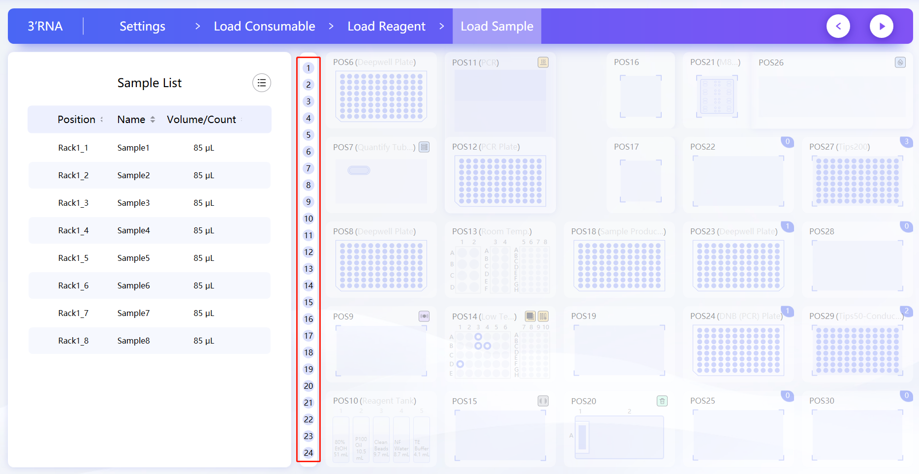
Figure 3-9 Sample Loading

Workflow Running
1) Enter the workflow running interface, check all consumables, reagents, and samples again, and after confirming that they are loaded correctly according to the instrument requirements, click "Run" and the instrument will start operating. In the workflow running interface, the previously selected running nodes and specific settings, the temperatures of the PCR and temperature control modules, as well as the current running stage and step will be displayed. Users can click "Pause" and "Resume" on the page to control the experimental workflow as needed, as shown in Figure 3-10.
- Note: Be sure to confirm that the instrument window is closed before starting the experiment. It is strictly prohibited to insert any part of the body into the instrument while it is running; otherwise, there is a risk of impact injury.
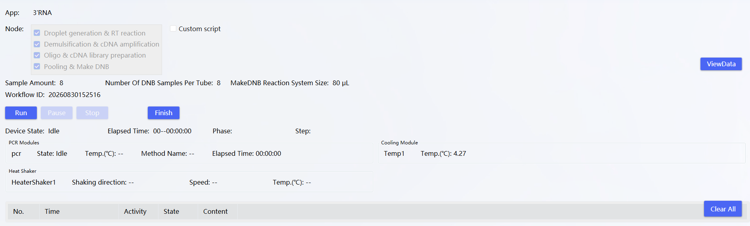
Figure 3-10 Workflow Running Interface

Description of Product Plate Sample Distribution
The single-cell integrated system runs 8 samples per batch, and the entire workflow is expected to take 14 hours. All intermediate products generated during the entire experimental workflow, including Oligo products, cDNA products, Oligo libraries, and cDNA libraries, are stored centrally in the POS18 product plate in order from left to right and from top to bottom, as shown in Figure 3-11.
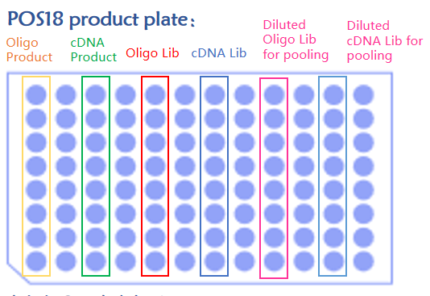
Figure 3-11 POS18 Product Plate Description
Product plate arrangement description:
Oligo products: column 1; cDNA products: columns 3
Oligo libraries: column 5; cDNA libraries: column 7
Diluted for pooling Oligo libraries: column 9
Diluted for pooling cDNA libraries: column 11
Product plate library concentration description:
Oligo & cDNA library (columns 5 to 8): After performing step 4, Pooling & Make DNB, the maximum library concentration is 30 ng/μL (if the concentration is greater than 30 ng/μL, dilute to 30 ng/μL). If step 4 is not performed, use the original concentration for quantification.
Diluted Oligo & cDNA libraries (columns 9 and 11): the final concentration should be in the range of 0.7 to 4 ng/μL.
DNB is stored in the PCR plate at POS12, as shown in Figure 3-12. Based on the parameters selected on the workflow setup page, the DNB arrangement rules are as described below. After the workflow is completed, remove the POS12 PCR plate and the Pos18 product plate. The DNBs in the POS12 PCR plate are loaded onto the sequencer and sequenced according to the sequencing method described in Chapter 4.
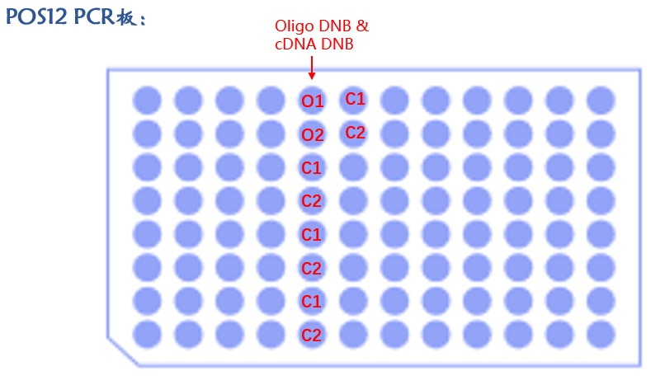
Figure 3-12 Example of DNB locations on the POS12 PCR plate
PCR plate DNB output arrangement
Starting from well 1 in column 5, the order is Oligo DNB followed by cDNA DNB. If the number of replication tubes is n, then the arrangement consists of n cycles of the number of DNB tubes. For example, if there are 2 DNB tubes, with 1 Oligo DNB replication tube and 4 cDNA DNB replication tubes, the order is as shown in the figure. O1, O2, C1, and C2 represent the DNBs of different samples. DNBs with the same identifier belong to the same sample and can be pooled. For example, the four C1 tubes and four C2 tubes shown in Figure 3-12.

Fragment Analysis
Take 1 μL each of the cDNA product, Oligo library, and cDNA library, and analyze the fragment size distribution using a nucleic acid fragment analyzer.

Quality Control Reference Values
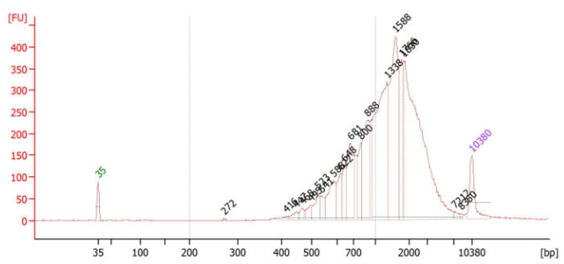
Figure 3-13 cDNA Product Fragment Size Distribution (Reference Trace Obtained Using 2100 Fragment Analyzer)
Reference values: cDNA product concentration greater than 10 ng/μL, with the main peak of the fragment size distribution between 600 and 2000 bp.
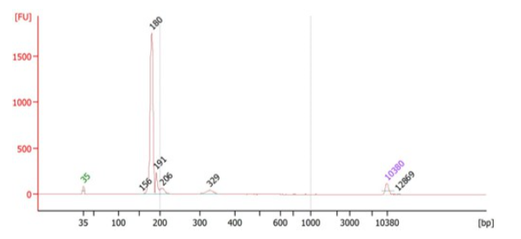
Figure 3-14 Oligo Library Fragment Size Distribution (Reference Trace Obtained Using 2100 Fragment Analyzer)
Reference values: Oligo library concentration greater than 10 ng/μL, with the main peak of the fragment size distribution at approximately 180 ± 10 bp.
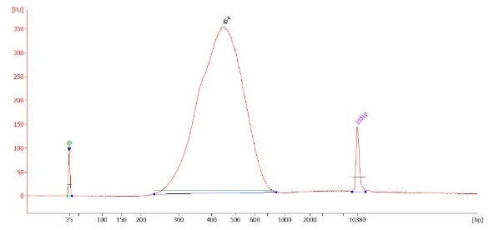
Figure 3-15 cDNA Library Fragment Size Distribution (Reference Trace Obtained Using 2100 Fragment Analyzer)
Reference values: cDNA library concentration greater than 10 ng/μL, with the main peak of the fragment size distribution between 300 and 550 bp. ~

Shutting Down the Instrument
Dispose of used sample tubes, reagent tubes that will not be reused, deep-well plates, PCR plates, and waste bags in the designated biomedical waste area. Clean the instrument workbench surface with purified water followed by disinfectant alcohol. If no additional experiments will be performed on the same day, clean the instrument again and shut down the software and the instrument as described in section 3.1.1 of this manual.

Sequencing
This chapter mainly introduces gene sequencers compatible with the libraries, the associated sequencing reagents, and the read lengths. The library structures are shown in Figures 4-1 and 4-2.
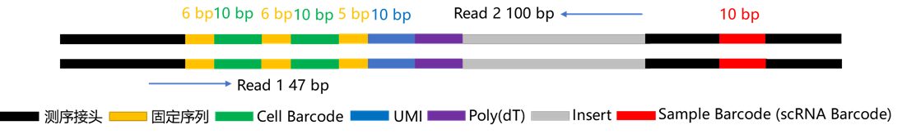
Figure 4-1 cDNA Library Structure

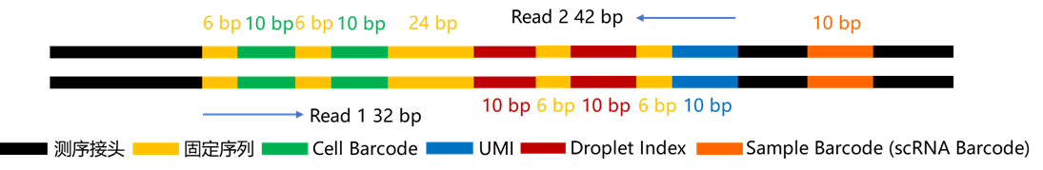
Figure 4-2 Oligo Library Structure
- Note:
[1] For cDNA libraries, after running the sequencing script, Reads 1 = 30 bp (including a 1-strand fixed sequence of 6 + 6 + 5 = 17 bp acquired in dark cycles) and Reads 2 = 100 bp.
[2] For Oligo libraries, after running the sequencing script, Reads 1 = 20 bp (including a 1-strand fixed sequence of 6 + 6 = 12 bp acquired in dark cycles) and Reads 2 = 30 bp (including a 2-strand fixed sequence of 6 + 6 = 12 bp acquired in dark cycles).

MGISEQ-2000RS Sequencing Platform Experimental Procedure

Preparation of Instruments, Reagents and Consumables:
Sequencer: MGISEQ-2000RS
MGISEQ-2000RS High-throughput Sequencing Reagent Kit (FCL PE100) (Cat. No. 1000012554)
MGISEQ-2000RS High-throughput Sequencing Reagent Kit (FCL PE150) (Cat. No. 1000012555)
Before performing sequencing, carefully read the corresponding manual, MGISEQ-2000RS High-throughput (Rapid) Sequencing Reagent Kit Operation Manual, and strictly follow the procedures described therein.

Sequencing Parameters
Table 4-1 MGISEQ-2000RS sequencing software versions and read lengths (pooling samples, sequencing barcode)
Library Type | cDNA Library |  |  |  |  | Oligo Library
Software version | ECR3.0 | ECR4.0 | ECR6.0 | ECR7.0 | ECR3.0 |  | ECR4.0 | ECR6.0 | ECR7.0
Control Software  Version: | ZebraV2Seq_1.4.0.184 and higher |  |  |  | ZebraV2Seq_1.4.0.184 and higher
Basecall  Version: | Basecall_1.0.8.208 and higher |  |  |  | Basecall_1.0.8.208 and higher
Sequencing Script | C4_scRNA_BC_PE47+  100+10 | C4_scRNA_BC_PE47+  100+10-ECR4.0 | Z_C4_scRNA_BC-ECR6.0 | Custom | C4_Oligo_  BC_PE32+  42+10 |  | C4_Oligo_  BC_PE32+  42+10-ECR4.0 | Z_C4_Oligo_BC-ECR6.0 | Custom
Reads 1 | 47 cycles (set the dark reaction at 1-6 bp, 17-22 bp, 33-37 bp) |  |  |  | 32 cycles (set the dark reaction at 1-6 bp, 17-22 bp)
Reads 2 | 100 cycles  10 cycles |  |  |  | 42 cycles (set the dark reaction at 11-16 bp, 27-32 bp)
Sample Barcode |  |  |  |  | 10 cycles
Sequencing Depth | > 60 k reads / cell |  |  |  | > 50 M reads / library
Table 4-2 MGISEQ-2000RS Sequencing Software Versions and Read Lengths (Without Sample Pooling, Without Barcode Sequencing)
Library Type | cDNA Library |  |  |  | Oligo Library
Software version | ECR3.0 | ECR4.0 | ECR6.0 | ECR7.0 | ECR3.0 | ECR4.0 | ECR6.0 | ECR7.0
Control Software  Version: | ZebraV2Seq_1.4.0.184 and higher |  |  |  | ZebraV2Seq_1.4.0.184 and higher
Basecall  Version: | Basecall_1.0.8.208 and higher |  |  |  | Basecall_1.0.8.208 and higher
Sequencing Script | C4_scRNA_noBC_PE47+100 | C4_scRNA_noBC_PE47+100-ECR4.0 | Z_C4_scRNA_noBC-  ECR6.0 | Custom | C4_Oligo_noBC_PE32+42 | C4_Oligo_  noBC_PE32+42-ECR4.0 | Z_C4_Oligo_noBC-ECR6.0 | Custom
Reads 1 | 47 cycles (set the dark reaction at 1-6 bp, 17-22 bp, 33-37 bp) |  |  |  | 32 cycles (set the dark reaction at 1-6 bp, 17-22 bp)
Reads 2 | 100 cycles |  |  |  | 42 cycles (set the dark reaction at 11-16 bp, 27-32 bp)
Sample Barcode | / |  |  |  | /
Sequencing Depth | > 60 k reads / cell |  |  |  | > 50 M reads / library

Experimental Procedure of the DNBSEQ-T7RS Sequencing Platform

Preparation of Instruments, Reagents and Consumables
Sequencer: DNBSEQ-T7RS
DNBSEQ-T7RS High-throughput Sequencing Reagent Kit (FCL PE100) V3.0 (Cat. No. 940-000269-00)
DNBSEQ-T7RS High-throughput Sequencing Reagent Kit (FCL PE150) V3.0 (Cat. No. 940-000268-00)
Before sequencing, please carefully read the corresponding manual, DNBSEQ T7RS High-throughput Sequencing Reagent Kit Operation Manual, and strictly follow the manual.

Sequencing Parameters
Table 4-3 DNBSEQ-T7RS Sequencing Software Versions and Read Lengths
Library Type | cDNA Library | Oligo Library
Software version | ECR 4.0 and above
Control software version | Version 1.4.1.812 and above
Basecall | 1.4.21.72_Ubuntu and above
Sequencing Script | Custom
Custom Primers | No
Reads 1 | 47 cycles (set the dark reaction at 1-6 bp, 17-22 bp, 33-37 bp) | 32 cycles (set the dark reaction at 1-6 bp, 17-22 bp)
Reads 2 | 100 cycles | 42 cycles (set the dark reaction at 11-16 bp, 27-32 bp)
Sample Barcode | 10 cycles | 10 cycles
Sequencing Depth | > 60 k reads / cell | > 50 M Reads / library

Appendix

Appendix A: Precautions Before Using DNA Clean Beads
- Before Using DNA Clean Beads (Hereinafter referred to as "magnetic beads"), retrieve them from the 4°C refrigerator 30 min in advance, vortex to mix thoroughly, and equilibrate to room temperature to ensure recovery efficiency.
- Before each use of magnetic beads, oscillate or invert upside down to ensure full mixing.
- The usage number of magnetic beads will directly affect the lower limit length of DNA fragment through purification. The higher the usage number of magnetic beads, the smaller the lower limit length of DNA fragment through purification.
.

Appendix B: Rules for the Use of Barcode Primer and Quantitative Reagents
This reagent kit provides 32 barcode primers. The barcode primers in the DNBelab C Series Single-cell Library Preparation Sample Tagging Kit S are designed based on the principle of base balance, and barcode combinations are selected through repeated experimental testing. To ensure optimal performance, please read this appendix carefully before use.  Please do not place it at a temperature higher than room temperature; otherwise, it will be easily degraded, thus affecting the use effect. Before use, barcode primers must be mixed and centrifuged. Wipe the tube cap clean with absorbent paper, and open the cap gently during use to prevent liquid splashing and avoid cross-contamination. Close the cap promptly after use.

B-1 Barcode Primer Use Rules
Based on the design principle of base balance, scRNA barcode primers should be used in groups or individually, among which
- Group 1: Barcode Primer-1~4 constitute one group of base-balanced barcodes; ~
- Group 2: Barcode Primer-5~8 constitute one group of base-balanced barcodes; ~
- Group 3: Barcode Primer-9~12 constitute one group of base-balanced barcodes; ~
- Group 4: Barcode Primer-13~16 constitute one group of base-balanced barcodes; ~
- Group 5: Barcode Primer-17~24 constitute one group of base-balanced barcodes;
- Group 6: Barcode Primer-25~32 constitute one group of base-balanced barcodes.
- There are six groups in total. When the required data volume for each sample is identical, please refer to the recommended barcode primer combination schemes in Table b-1 for different numbers of samples.

Table B-1 Barcode Primer Use Rules
Sample size/lane | Method1 | Method2 | Method3 | Method4 | Method5 | Method6
1 | 1 ~ 4 | 5 ~ 8 | 9 ~ 12 | 13 ~ 16 | 17~24 | 25~32
2 | Sample 1: 1 ~ 2  Sample 2: 3 ~ 4 | Sample 1: 5 ~ 6  Sample 2: 7 ~ 8 | Sample 1: 9 ~ 10  Sample 2: 11 ~ 12 | Sample 1: 13 ~ 14  Sample 2: 15 ~ 16 | Sample 1: 17~20  Sample 2: 21~24 | Sample 1: 25~28  Sample 2: 29~32
3 | Sample 1: 1  Sample 2: 2  Sample 3: 3 ~ 4 | Sample 1: 5  Sample 2: 6  Sample 3: 7 ~ 8 | Sample 1: 9  Sample 2: 10  Sample 3: 11 ~ 12 | Sample 1: 13  Sample 2: 14  Sample 3: 15 ~ 16 | Sample 1: 17~18  Sample 2: 19~20  Sample 3: 21~24 | Sample 1: 25~26  Sample 2: 27~28  Sample 3: 29~32
4 | Sample 1: 1  Sample 2: 2  Sample 3: 3  Sample 4: 4 | Sample 1: 5  Sample 2: 6  Sample 3: 7  Sample 4: 8 | Sample 1: 9  Sample 2: 10  Sample 3: 11  Sample 4: 12 | Sample 1: 13  Sample 2: 14  Sample 3: 15  Sample 4: 16 | Sample 1: 17~18  Sample 2: 19~20  Sample 3: 21~22  Sample 4: 23~24 | Sample 1: 25~26  Sample 2: 27~28  Sample 3: 29~30  Sample 4: 31~32

Sample size/lane | Method 1 | Method 2 | Method 3 | Method 4 | Method 5 | Method 6
5 | Sample 1: 1  Sample 2: 2  Sample 3: 3  Sample 4: 4  Sample 5: Select 1 group from the remaining 3 groups. | Sample 1: 5  Sample 2: 6  Sample 3: 7  Sample 4: 8  Sample 5: Select 1 group from the remaining 3 groups. | Sample 1: 9  Sample 2: 10  Sample 3: 11  Sample 4: 12  Sample 5: Select 1 group from the remaining 3 groups. | Sample 1: 13  Sample 2: 14  Sample 3: 15  Sample 4: 16  Sample 5: Select 1 group from the remaining 3 groups. | Sample 1: 17  Sample 2: 18  Sample 3: 19  Sample 4: 20  Sample 5: 21~24 | Sample 1: 25  Sample 2: 26  Sample 3: 27  Sample 4: 28  Sample 5: 29~32
6 | Sample 1: 1  Sample 2: 2  Sample 3: 3  Sample 4: 4  Samples 5 and 6: Select any 2 groups from the remaining 3 groups. | Sample 1: 5  Sample 2: 6  Sample 3: 7  Sample 4: 8  Sample 5: Select 1 group from the remaining 3 groups. | Sample 1: 9  Sample 2: 10  Sample 3: 11  Sample 4: 12  Samples 5 and 6: Select any 2 groups from the remaining 3 groups. | Sample 1: 13  Sample 2: 14  Sample 3: 15  Sample 4: 16  Samples 5 and 6: Select any 2 groups from the remaining 3 groups. | Sample 1: 17  Sample 2: 18  Sample 3: 19  Sample 4: 20  Sample 5◼~22: 21  Sample 6◼3~24: 2 | Sample 1: 25  Sample 2: 26  Sample 3: 27  Sample 4: 28  Sample 5: 29~30  Sample 6: ◼31~32
7 | Sample 1: 1  Sample 2: 2  Sample 3: 3  Sample 4: 4  Samples 5-7: Select combinations based on 3 samples/lane. | Sample 1: 5  Sample 2: 6  Sample 3: 7  Sample 4: 8  Samples 5-7: Select combinations based on 3 samples/lane. | Sample 1: 9  Sample 2: 10  Sample 3: 11  Sample 4: 12  Samples 5-7: Select combinations based on 3 samples/lane. | Sample 1: 13  Sample 2: 14  Sample 3: 15  Sample 4: 16  Samples 5-7: Select combinations based on 3 samples/lane. | Sample 1: 17  Sample 2: 18  Sample 3: 19  Sample 4: 20  Sample 5: 21  Sample 6: 22  Sample 7: 23~24 | Sample 1: 25  Sample 2: 26  Sample 3: 27  Sample 4: 28  Sample 5: 29  Sample 6: 30  Sample 7: 31~32
8 | Choose any 2 out of 4 sets of barcode primers. |  |  |  | 17~24 | 25~32
(x=1~8, 9~16 in total) | Operate in two steps:  1. Samples 1 to 8 are divided into 1 group, and barcode primers are added using the above method (8 samples/lane).  2. Divide the remaining samples into 1 group. Based on the value of X, add barcode primers using the corresponding 1 to 8 samples/lane method described above, and ensure that different groups of barcode primers are added according to the specified requirements.
- Note: For samples requiring mixed barcode primers, equal volumes of N barcode primers must be combined to prepare a homogeneous mix before being added to the samples.

Rules for the use of quantitative reagents
dsDNA quantification Mix-1, Mix-3, and Mix-5, and ssDNA quantification Mix-1 are used when the DNA concentration is less than 50 ng/μL. dsDNA quantification Mix-2, Mix-4, and Mix-6, and ssDNA quantification Mix-2 are used to dilute and retest the mixture when the concentration is greater than 50 ng/μL. Therefore, if the concentration is less than 50 ng/μL, this tube does not need to be placed in order to avoid reagent waste.

Appendix C: Guidelines for Flexible-throughput Reagent Aliquoting
Based on the number of samples for different throughputs (1-8), list the aliquot volumes for room temperature reagents, low temperature reagents, and reagent reservoir reagents separately.
Room Temperature Reagents
Reagent Name | Consumable Name | 1RXN | 2RXN | 3RXN | 4RXN | 5RXN | 6RXN | 7RXN | 8RXN
dsDNA quantification Mix-1 (μL) | 5 mL cryovial (with cap) | 817.6 | 1055.2 | 1292.8 | 1530.4 | 1768 | 2005.6 | 2243.2 | 2480.8
dsDNA quantification Mix-2 (μL) | 5 mL cryovial (with cap) | 392 | 584 | 776 | 968 | 1160 | 1352 | 1544 | 1736
dsDNA quantification Mix-3 (μL) | 5 mL cryovial (with cap) | 817.6 | 1055.2 | 1292.8 | 1530.4 | 1768 | 2005.6 | 2243.2 | 2480.8
dsDNA quantification Mix-4 (μL) | 5 mL cryovial (with cap) | 296 | 392 | 488 | 584 | 680 | 776 | 872 | 968
dsDNA quantification Mix-5 (μL) | 5 mL cryovial (with cap) | 817.6 | 1055.2 | 1292.8 | 1530.4 | 1768 | 2005.6 | 2243.2 | 2480.8
dsDNA quantification Mix-6 (μL) | 5 mL cryovial (with cap) | 296 | 392 | 488 | 584 | 680 | 776 | 872 | 968
ssDNA quantification Mix-1 (μL) | 5 mL cryovial (with cap) | 1055.2 | 1292.8 | 1530.4 | 1768 | 2005.6 | 2243.2 | 2480.8 | 2718.4
ssDNA quantification Mix-2 (μL) | 5 mL cryovial (with cap) | 392 | 488 | 584 | 680 | 776 | 872 | 968 | 1064
Magnetic bead phase (μL) | 8-tube strips (800 μL) | 110 μL/well
- Note: The 5 mL cryovial must be capped with the MGI 5 mL cryovial rubber stopper (catalog number: 012-000818-00) before being placed in the corresponding position on the instrument.

Low Temperature Reagents
Reagent Name | Consumable Name | 1RXN | 2RXN | 3RXN | 4RXN | 5RXN | 6RXN | 7RXN | 8RXN
Breakage  Reagent (μL) | 2.0 mL cryovial, PCR grade | 140 | 250 | 360 | 470 | 580 | 690 | 800 | 910
cDNA Amp  Enzyme (μL) | 2.0 mL cryovial, PCR grade | 80 | 140 | 200 | 260 | 320 | 380 | 440 | 500
cDNA Amp  Primer-V3 (μL) | 0.5 mL cryovial, PCR grade | 14.8 | 19.6 | 24.4 | 29.2 | 34 | 38.8 | 46.3 | 48.4
PCR Amp  Enzyme (μL) | 2.0 mL cryovial, PCR grade | 110 | 200 | 290 | 380 | 470 | 560 | 650 | 740
Frag  Buffer-V3 (μL) | 0.5 mL cryovial, PCR grade | 16 | 22 | 28 | 34 | 40 | 46 | 52 | 58
Frag  Enzyme-V3 (μL) | 0.5 mL cryovial, PCR grade | 22 | 34 | 46 | 58 | 70 | 82 | 94 | 106
Ligation  Buffer-V3 (μL) | 0.5 mL cryovial, PCR grade | 34 | 58 | 82 | 106 | 130 | 154 | 178 | 202
DNA  Ligase-V3 (μL) | 0.5 mL cryovial, PCR grade | 22 | 34 | 46 | 58 | 70 | 82 | 94 | 106
scRNA  Adapter-V3 (μL) | 0.5 mL cryovial, PCR grade | 16 | 22 | 28 | 34 | 40 | 46 | 52 | 58
dsDNA quantification  Standard ST1 (μL) | 0.5 mL cryovial, PCR grade | 40
dsDNA quantification  Standard ST2 (μL) | 0.5 mL cryovial, PCR grade | 40
ssDNA quantification  Standard ST1 (μL) | 0.5 mL cryovial, PCR grade | 20
ssDNA quantification  Standard ST2 (μL) | 0.5 mL cryovial, PCR grade | 20
scRNA Barcode Primer (μL) | 8-tube strips (200 μL) | 10 μL/well

MAKE DNB reagent (DNBSEQ One-Step DNB Preparation Kit V4.0, catalog number: 940-001653-00)
Reagent Name | Consumable Name | 2 tubes | 3 tubes | 4 tubes | 5 tubes | 6 tubes | 7 tubes | 8 tubes | 9 tubes | 10 tubes
TE buffer (μL) | 2.0 mL cryovial, PCR grade | 78 | 102 | 126 | 150 | 174 | 198 | 222 | 246 | 270
DNB preparation buffer (μL) | 0.5 mL cryovial, PCR grade | 44 | 92 | 116 | 140 | 164 | 188 | 212 | 236 | 260
DNB polymerase mixture I (μL) | 2.0 mL cryovial, PCR grade | 106 | 154 | 202 | 250 | 298 | 346 | 394 | 442 | 490
DNB polymerase mixture II (μL) | 0.5 mL cryovial, PCR grade | 7.8 | 10.2 | 12.6 | 15 | 17.4 | 19.8 | 22.2 | 24.6 | 27
DNB termination buffer (μL), suitable for PE100 | 8-tube strips (200 μL) | 25 μL/well |  |  |  |  |  |  | POS14 10A, 50 μL/well; 10B–10H, 25 μL/well each | POS14 10A and 10B, 50 μL/well each; 10C–10H, 25 μL/well each
DNB termination buffer (μL), suitable for PE150 | 8-tube strips (200 μL) | 15 μL/well |  |  |  |  |  |  | POS14 10A, 30 μL/well; 10B–10H, 15 μL/well each | POS14 10A and 10B, 30 μL/well each; 10C–10H, 15 μL/well each
- Note: The maximum number of DNB tubes that can be prepared is 10. If more than 10 tubes are prepared, pipette tips may be insufficient.

Reagent reservoir reagent
Reagent Name | Consumable Name | 1RXN | 2RXN | 3RXN | 4RXN | 5RXN | 6RXN | 7RXN | 8RXN
80% ethanol (mL) | 50 mL single-well reservoir and reservoir lid set | 27.5 | 32.6 | 35.7 | 38.8 | 41.8 | 44.8 | 47.9 | 51
P100 Oil (mL) | 50 mL single-well reservoir and reservoir lid set | 3.5 | 4.5 | 5.5 | 6.5 | 7.5 | 8.5 | 9.5 | 10.5
Clean beads (mL) | 50 mL single-well reservoir and reservoir lid set | 3.4 | 4.3 | 5.2 | 6.1 | 7 | 7.9 | 8.8 | 9.7
NF water (mL) | 50 mL single-well reservoir and reservoir lid set | 5.5 | 5.9 | 6.4 | 6.8 | 7.3 | 7.7 | 8.2 | 8.7
TE Buffer (mL) | 50 mL single-well reservoir and reservoir lid set | 2.7 | 2.9 | 3.1 | 3.3 | 3.5 | 3.7 | 3.8 | 4.1

Appendix D: Guidelines for Preparation of Flexible-throughput Cell Phase and Magnetic Bead Phase
Based on the different sample throughputs (1–8) of the integrated system, separate preparation tables are provided for the cell phase and the magnetic bead phase. RT Enzyme-V3 should be added to the cell phase as the final component immediately before loading onto the instrument, and mixed thoroughly.
Cell phase (1.13×)
Reagent Name | 1RXN | 2RXN | 3RXN | 4RXN | 5RXN | 6RXN | 7RXN | 8RXN
Cell Solution-V3 (μL) | 20.00 | 40.00 | 60.00 | 80.00 | 100.01 | 120.01 | 140.01 | 160.01
RT Primer-V3 (μL) | 4.52 | 9.04 | 13.56 | 18.08 | 22.60 | 27.12 | 31.64 | 36.16
DIR Reagent-V3 (μL) | 1.81 | 3.62 | 5.42 | 7.23 | 9.04 | 10.85 | 12.66 | 14.46
RNase Inhibitor (μL) | 18.65 | 37.29 | 55.94 | 74.58 | 93.23 | 111.87 | 130.52 | 149.16
RT Enzyme-V3 (μL) | 9.04 | 18.08 | 27.12 | 36.16 | 45.20 | 54.24 | 63.28 | 72.32
PBS+Cell (μL) | 36.39 | 72.77 | 109.16 | 145.54 | 181.93 | 218.32 | 254.70 | 291.09

Magnetic bead phase (1.13×)
Reagent Name | 1RXN | 2RXN | 3RXN | 4RXN | 5RXN | 6RXN | 7RXN | 8RXN
Cell Beads-V3 (μL) | 79.10 | 158.20 | 237.30 | 316.40 | 395.50 | 474.60 | 553.70 | 632.80
Index Carrier (μL) | 39.55 | 79.10 | 118.65 | 158.20 | 197.75 | 237.30 | 276.85 | 316.40
Beads Buffer (μL) | 102.83 | 205.66 | 308.49 | 411.32 | 514.15 | 616.98 | 719.81 | 822.64
Lysis Buffer-V3 (μL) | 10.17 | 20.34 | 30.51 | 40.68 | 50.85 | 61.02 | 71.19 | 81.36

The operating steps for preparation of the magnetic bead phase are as follows:
1. Retrieve Cell Beads-V3 and Index Carrier, and mix thoroughly by inversion or by gentle pipetting.
2. Based on the sample throughput, aspirate Cell Beads-V3 and Index Carrier into appropriately sized low-binding
centrifuge tubes according to the table above.
3. Place the centrifuge tubes on a magnetic stand and incubate for 3–5 minutes. Carefully discard the supernatant to avoid loss of magnetic beads.
4. Remove the centrifuge tubes from the magnetic stand, add Beads Buffer and Lysis Buffer-V3 sequentially according to the table above, and place on ice until use.

Appendix E: Reference Table of Consumable Usage for 1–8 Throughputs in the Entire Workflow

Consumable Name | 1RXN | 2RXN | 3RXN | 4RXN | 5RXN | 6RXN | 7RXN | 8RXN
50 μL conductive pipette tips with filter, boxed (box) | 1 | 2 | 2 | 3 | 3 | 3 | 4 | 4
200 μL transparent pipette tips with filter, boxed (box) | 1 | 2 | 2 | 3 | 3 | 4 | 4 | 5
1000 μL transparent pipette tips with filter, boxed (box) | 1 | 1 | 1 | 1 | 1 | 1 | 1 | 1
50 mL single-well reservoir and cap set (box) | 5
100 mL single-well reservoir and cap set (box) | 1
1.3 mL round-well U-bottom deep-well plate (each) | 2
1.2 mL round-well U-bottom filter-membrane deep-well plate (each) | 1
PCR plate sealing gasket (each) | 1
0.2 mL 96-well full-skirt PCR plate (each) | 3
Breakable PCR 8-tube strips and caps (200 μL) (each) | 1
MGISP-100 100–800 μL breakable 8-tube strips (each) | 1
2.0 mL cryovial, PCR grade (each) | 4
0.5 mL cryovial, PCR grade (each) | 4
5 mL cryovial with cap (each) | 8
MGI 5 mL cryovial rubber stopper (each) | 8
0.5 mL transparent thin-walled tube (each) | 1
M8 slide (each) | 1 |  | 2 |  | 3 |  | 4

Appendix F: Silicone Pad for Replacing the PCR Cover Plate
It is recommended to replace the silicone pad on the top cover of the PCR module after 20 experiments. The operating steps are as follows:
1. On the main software interface, select single-step operation, select the PCR module, and click "Close Door" to close the PCR instrument door.
2. Turn off the instrument power.
Click the [  ] icon in the upper right corner of the interface, then click [Close] > [OK] to exit the control software.
On the computer desktop, click the [  ] button, select [  ], and shut down the computer.
3. Wear personal protective equipment.
4. Open the viewing window.
5. Press below the latch of the PCR module top cover plate with both thumbs to open the top cover plate.

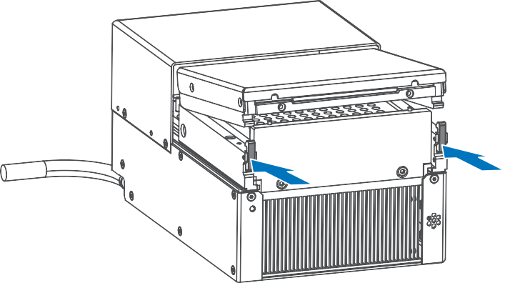
PCR module top cover plate latch position
6. Remove the silicone pad from the top cover plate of the PCR module and discard it into the designated waste bin marked with a biohazard symbol.
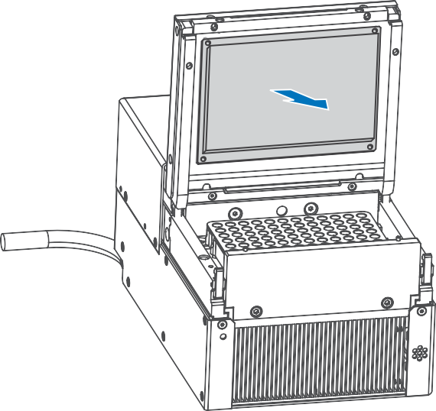
Remove the silicone pad from the top cover plate of the PCR module.

7. Install a new silicone pad, ensuring that the surface is level and free of air bubbles.
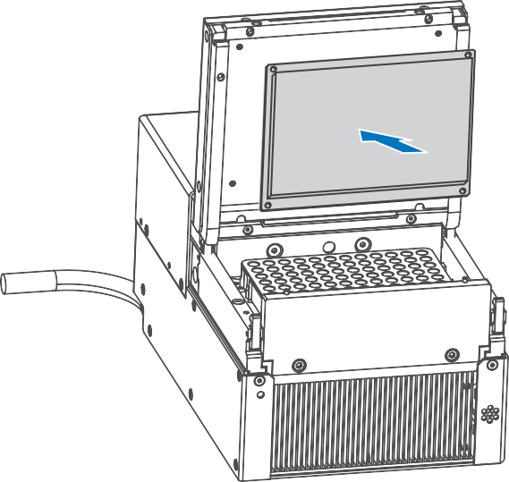
Install a new silicone pad
8. Place the top cover plate on the PCR module and press the sealing strip inward. Once the top cover plate is fully lowered, use the latch to secure the top cover plate.
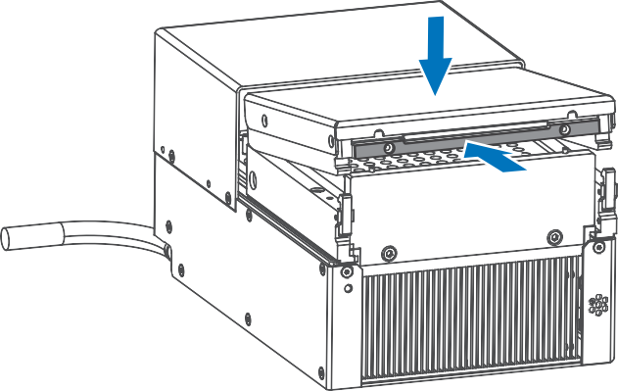
A:
(B √)
Close the top cover plate of the PCR module.
Official WeChat
Contact Us
Manufacturer: Qingdao MGI Tech Co., Ltd.
Production address: Building 4, No. 2 Hengyunshan Road, Qingdao Area, China (Shandong) Pilot Free Trade Zone
Customer service hotline: 4000-688-114
Technical support: MGI-service@mgi-tech.com
Website: www.mgi-tech.com
Official WeChat
Contact Us
Manufacturer: Qingdao MGI Tech Co., Ltd.
Production address: Building 4, No. 2 Hengyunshan Road, Qingdao Area, China (Shandong) Pilot Free Trade Zone
Customer service hotline: 4000-688-114
Technical support: MGI-service@mgi-tech.com
Website: www.mgi-tech.com

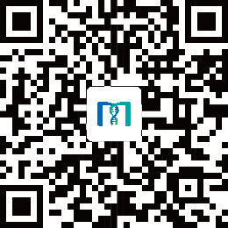
Official WeChat

Contact Us
Manufacturer: Qingdao MGI Tech Co., Ltd.
Production address: Building 4, No. 2 Hengyunshan Road, Qingdao Area, China (Shandong) Pilot Free Trade Zone
Customer Service Hotline:
Technical Support:
Website:

